############################# Pre-requisite ####################################

# # **Management Kubernetes cluster**

* This is the management cluster and is used to host Crossplane and ArgoCD

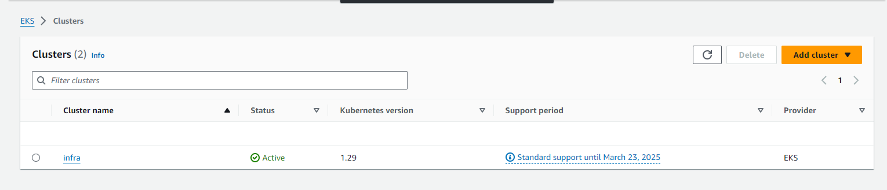

##############Provision EKS on AWS using Crossplane and ArgoCD #########

https://github.com/hoanglecao/argocd-crossplane/tree/main/infrastructure/argocd/crossplane/aws

1. **Create an Application in ArgoCD**

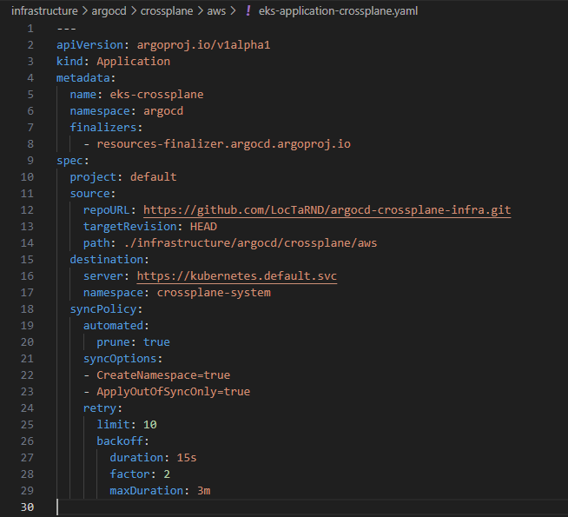

Deploy the application: kubectl apply -f eks-application-crossplane.yaml

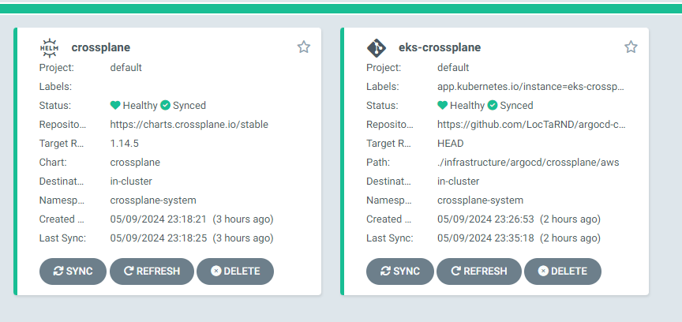

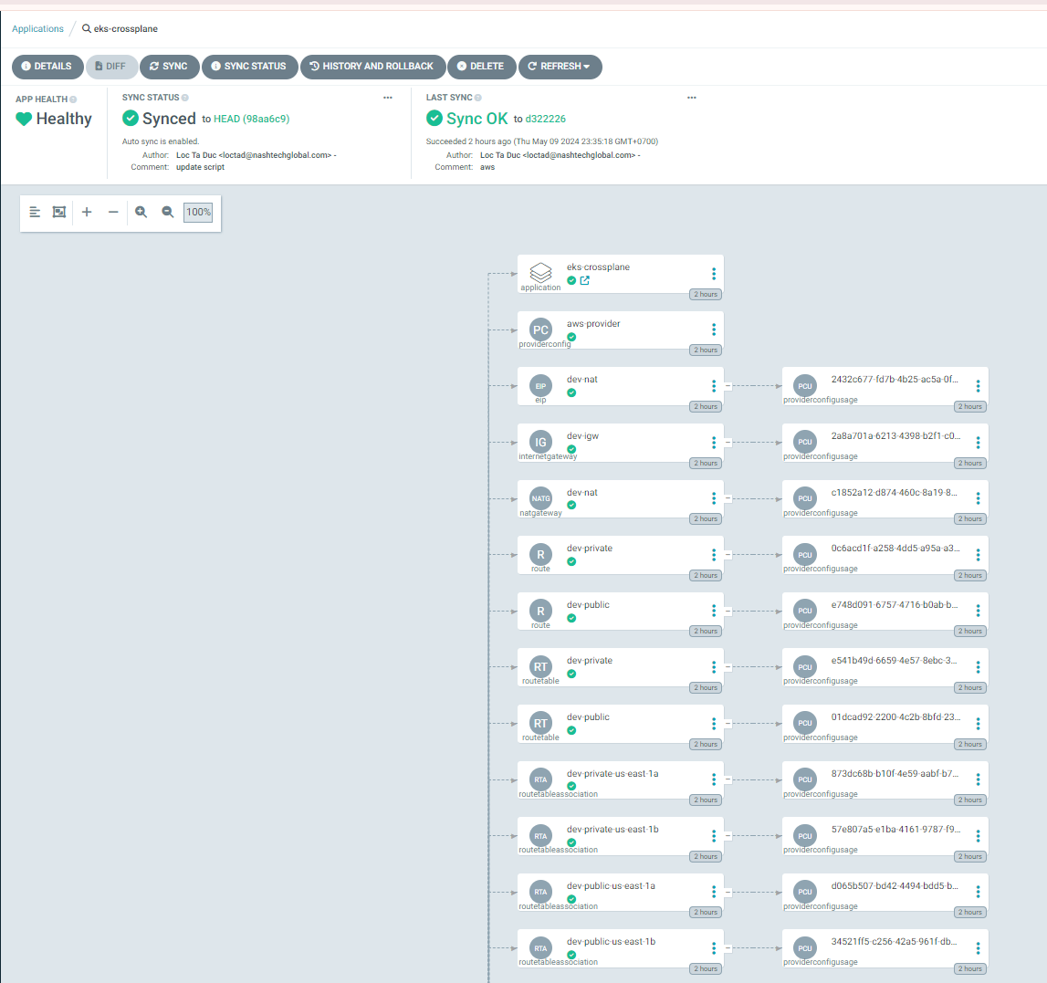

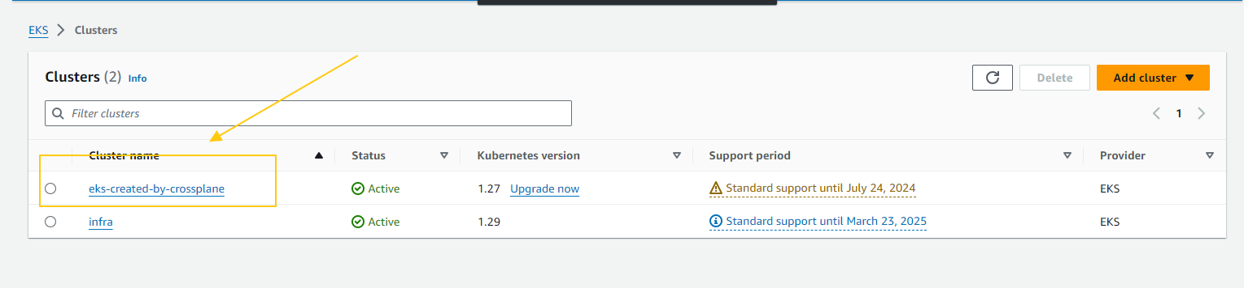

###################Provision AKS on Azure using Crossplane ##################

https://github.com/hoanglecao/argocd-crossplane/tree/main/infrastructure/crossplane-config/azure

**1. Create an Application in ArgoCD**

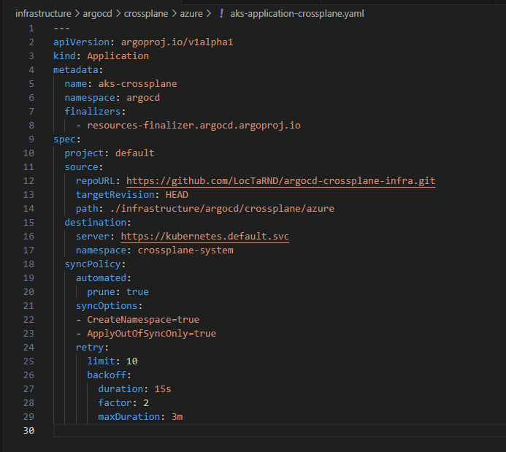

Apply it: kubectl apply -f aks-application-crossplane.yaml

